SUPPLEMENTARY DATA
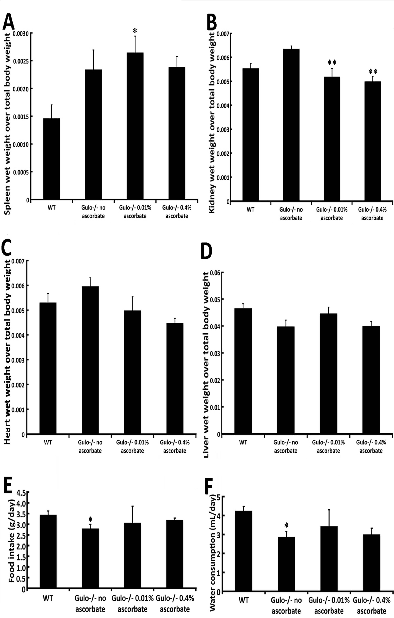

Figure S1. Impact of ascorbate on the weight of different organs in Gulo^{-/-} mice treated with different amounts of ascorbate. (A) Histogram representing the ratio of spleen wet weight over total body weight. (Tukey post ANOVA test *P < 0.05 compared to wild type mice). (B) Histogram representing the ratio of kidney wet weight over total body weight. (Tukey post ANOVA test **P < 0.01 compared to ascorbate depleted Gulo^{-/-} mice). (C) Histogram representing the ratio of heart wet weight over total body weight. (D) Histogram representing the ratio of liver wet weight over total body weight. (E) Histogram representing food intake. (ANOVA: P > 0.05 but student t-test: *P < 0.05 compared to wild type mice). (F) Histogram representing water consumption. Bars in all histograms represent SEM. (ANOVA: P > 0.05 but student t-test: *P < 0.05 compared to wild type mice). One cohort of Gulo^{-/-} mice was treated with 0.01% of ascorbate (w/v) in drinking water from weaning to four months of age. A second cohort of Gulo^{-/-} mice was treated with 0.4% of ascorbate from weaning to four months of age. In a third cohort of Gulo^{-/-} mice, ascorbate was omitted from the drinking water at the age of three months for four weeks. Wild type mice were not treated with vitamin C. N=6 males for each cohort.

www.impactaging.com 1 AGING, February 2016, Vol. 8 No.2

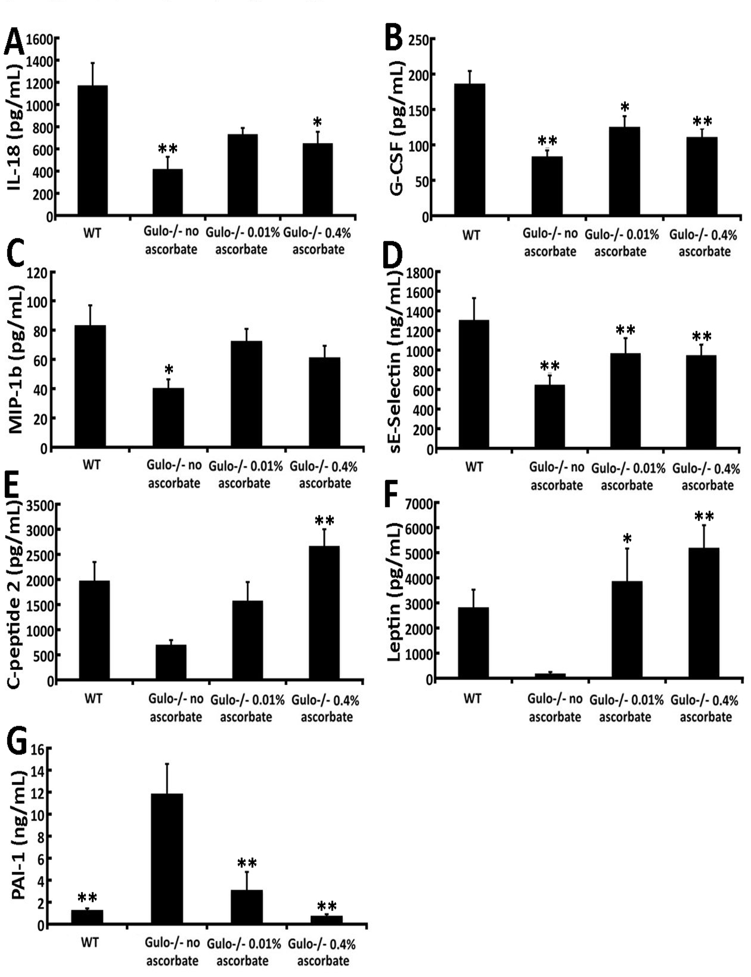

Figure S2. Serum level of seven serum cytokines significantly altered in Gulo^{-/-} mice treated with different amount of ascorbate. (A) IL-18 (Tukey post ANOVA test: *P < 0.05 and **P < 0.01 compared to wild type mice). (B) G-CSF (Tukey post ANOVA test: *P < 0.05 and **P < 0.01 compared to wild type mice). (C) MIP-1b (Tukey post ANOVA test: *P < 0.05 compared to wild type mice). (D) sE-Selectin (Tukey post ANOVA test: **P < 0.01 compared to wild type mice). (E) C-peptide 2 (Tukey post ANOVA test: **P < 0.01 compared to ascorbate depleted Gulo^{-/-} mice). (F) Leptin (Tukey post ANOVA test: *P < 0.05 and **P < 0.01 compared to ascorbate depleted Gulo^{-/-} mice). (G) PAI-1 (Tukey post ANOVA test: **P < 0.01 compared to ascorbate depleted Gulo^{-/-} mice). One cohort of Gulo^{-/-} mice was treated with 0.01% of ascorbate (w/v) in drinking water from weaning to four months of age. A second cohort of Gulo^{-/-} mice was treated with 0.4% of ascorbate from weaning to four months of age. In a third cohort of Gulo^{-/-} mice, ascorbate was omitted from the drinking water at the age of three months for four weeks. Wild type mice were not treated with vitamin C. N=8 males for each cohort.

www.impactaging.com 2 AGING, February 2016, Vol. 8 No.2

Figure S3. Impact of ascorbate on sinusoidal endothelial fenestration in Gulo^{-/-} mice treated with different amount of ascorbate. (A) Frequency of fenestrae/surface hepatocyte area in the different cohorts of mice. (B) Average fenestration diameter in the different cohorts of mice. (C) Examples of scanning electron microscopy showing lumenal surface of the liver sinusoidal endothelium with fenestrations clustered into sieve plates in wild type and Gulo^{-/-} mice treated with different concentrations of ascorbate.

www.impactaging.com 3 AGING, February 2016, Vol. 8 No.2

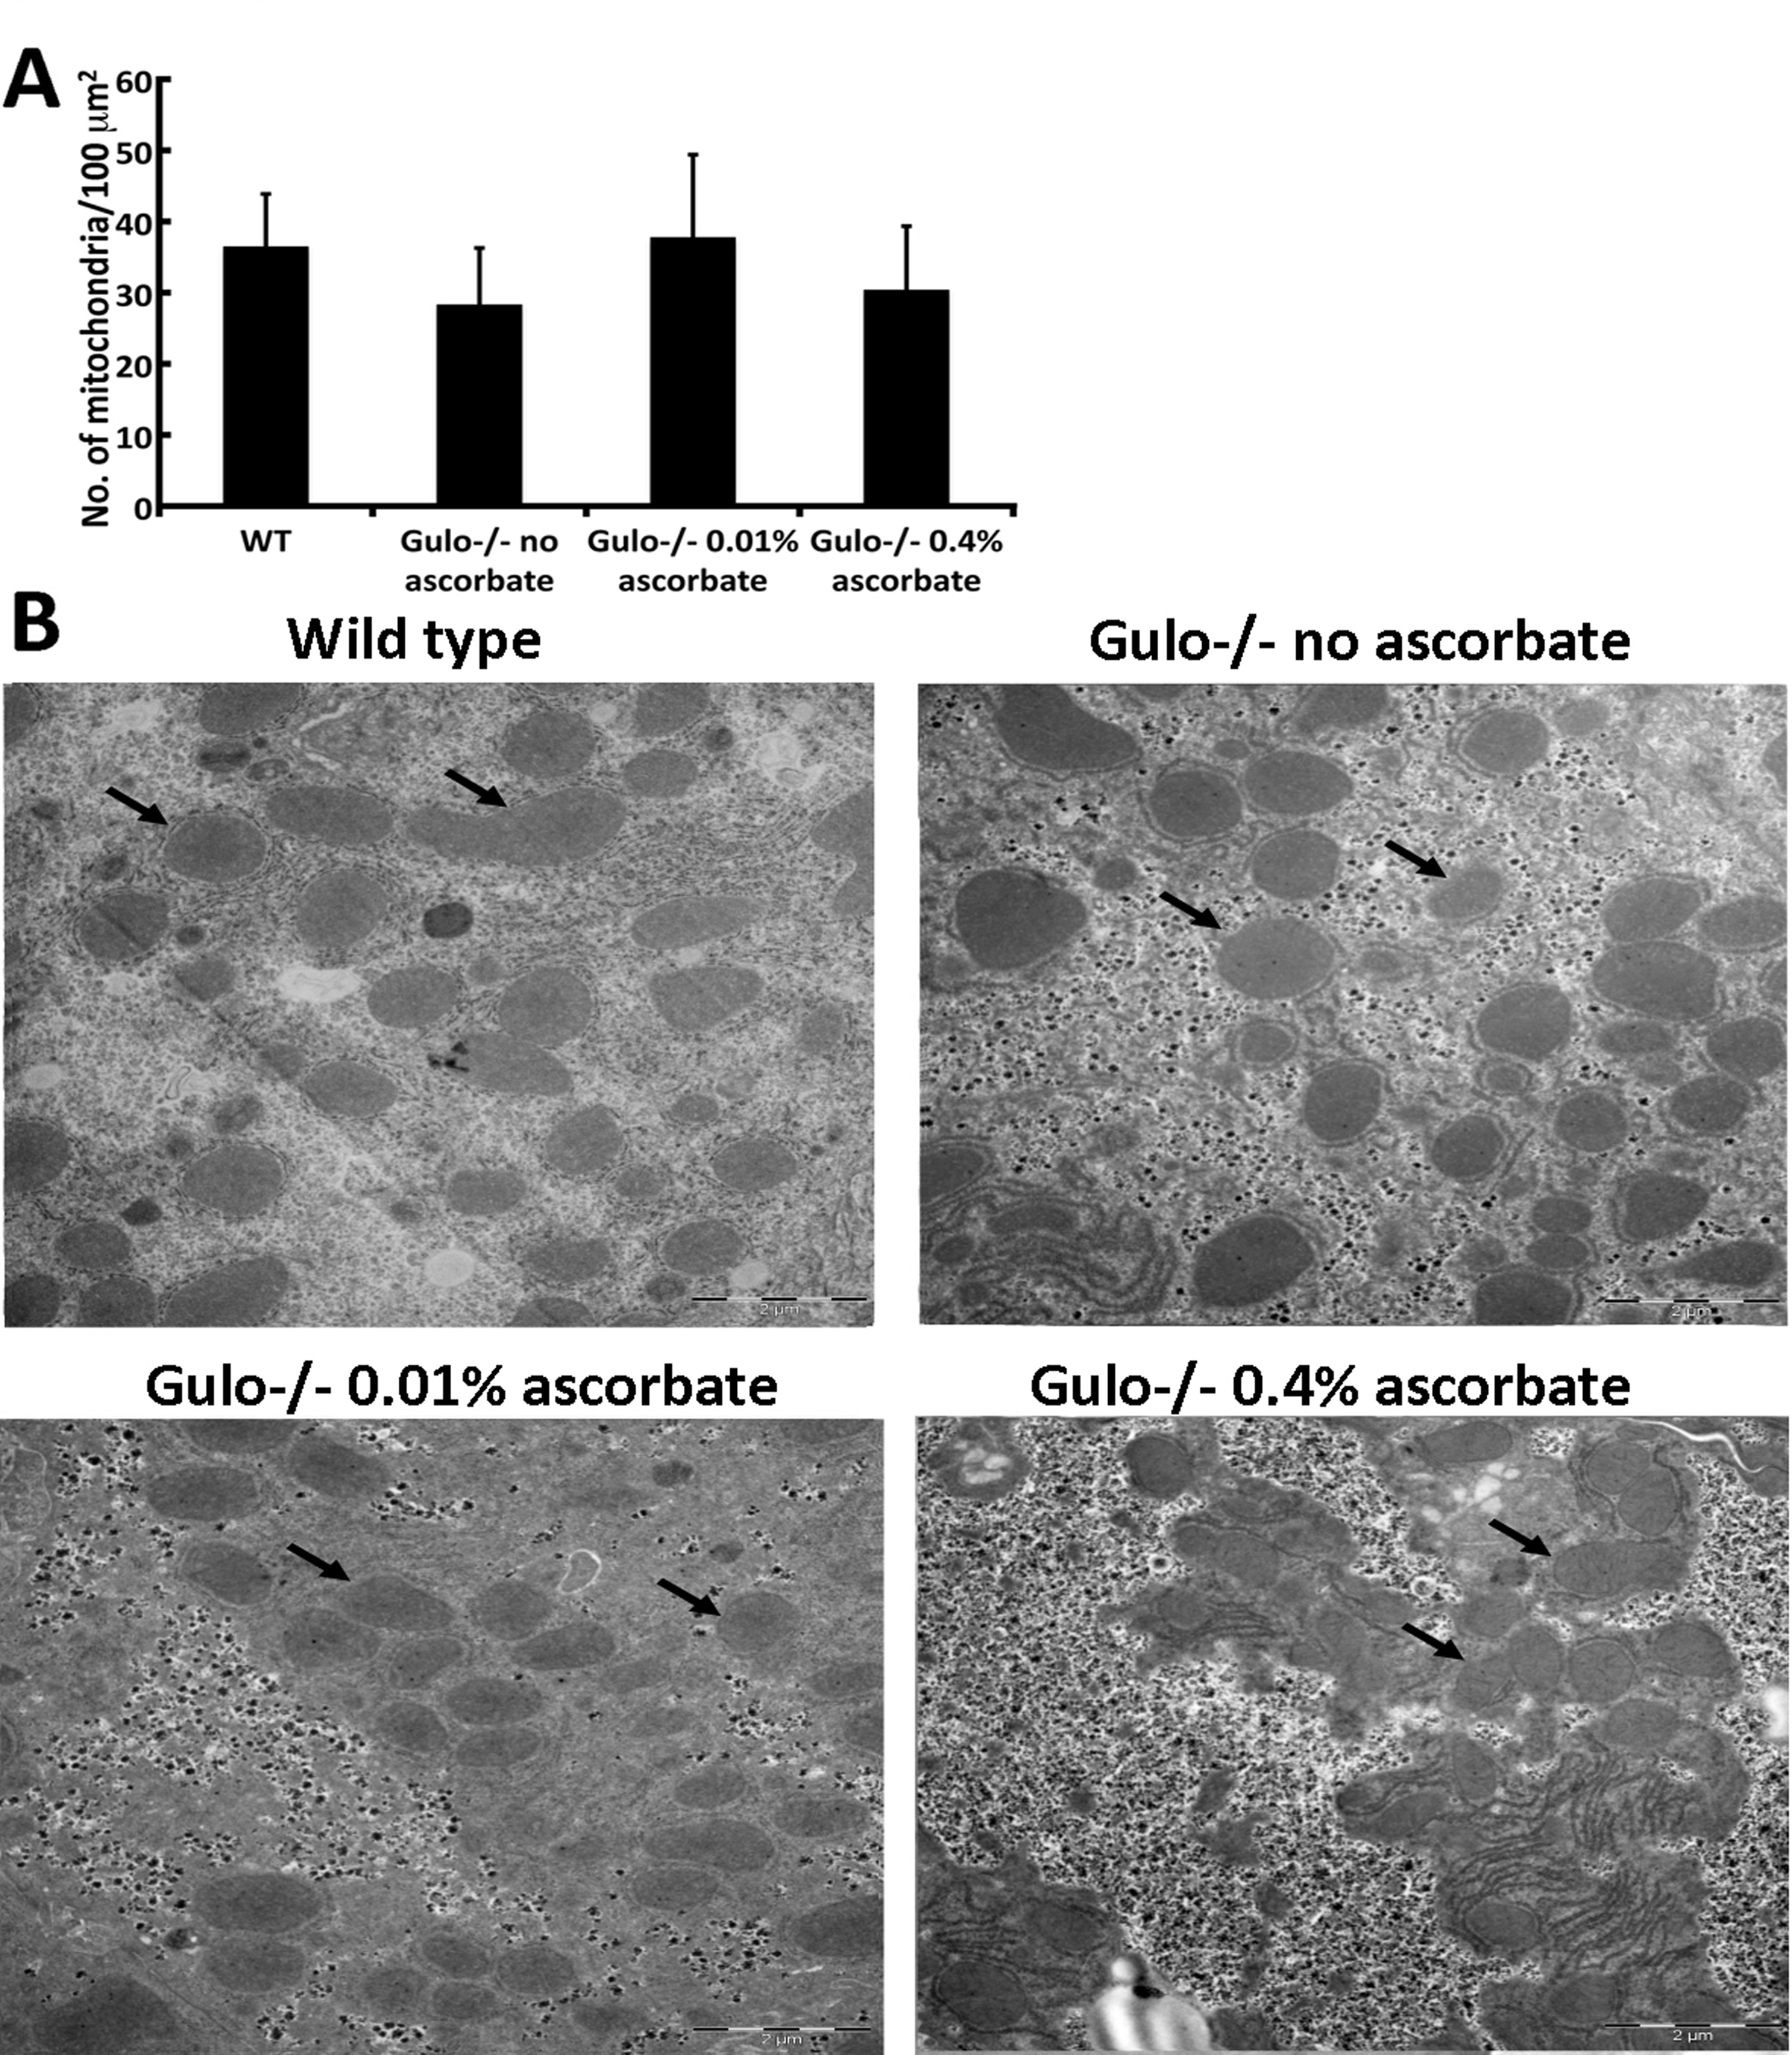

Figure S4. Impact of ascorbate on the number of mitochondria/hepatocyte surface area in Gulo^{-/-} mice treated with different amount of ascorbate. (A) Graph showing the frequency of mitochondria/hepatic surface area. (B) Examples of transmission electron microscopy showing mitochondrial size in wild type and Gulo^{-/-} mice treated with different concentrations of ascorbate. Arrows point to mitochondria.

www.impactaging.com 4 AGING, February 2016, Vol. 8 No.2

