SUPPLEMENTARY DATA

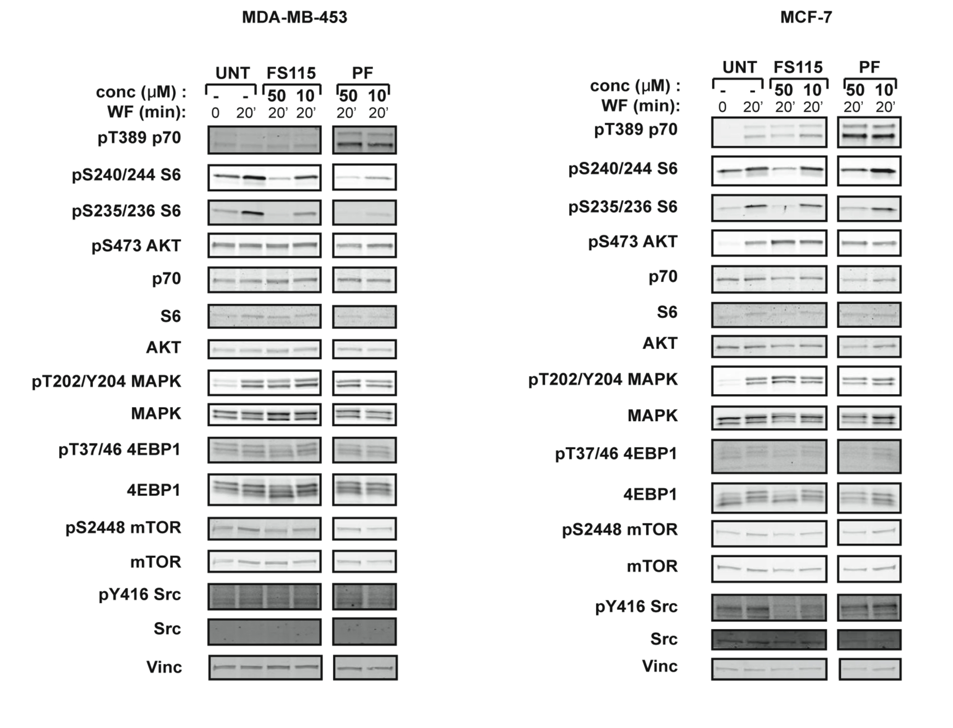

Supplementary Figure S1. FS-115 inhibits p70S6K1 in different breast cancer cell lines. (A) Western blot analysis of MDA-MB-453 breast cancer cells, serum starved (time 0) and then stimulated for 20 minutes with wound fluids (WF) or serum starved, pre-treated 30 minutes with FS-115 or PF-4708671 (50-10-5-1μM, as indicated) then stimulated for 20 minutes with WF, always in the presence of the inhibitor. p70S6K, AKT, MAPK, mTOR and Src signalling pathways were analyzed. Vinculin was used as loading control. (B) Same as in (A) but in MCF-7 breast cancer cells.

www.impactaging.com 1 AGING, May 2016, Vol. 8 No.5

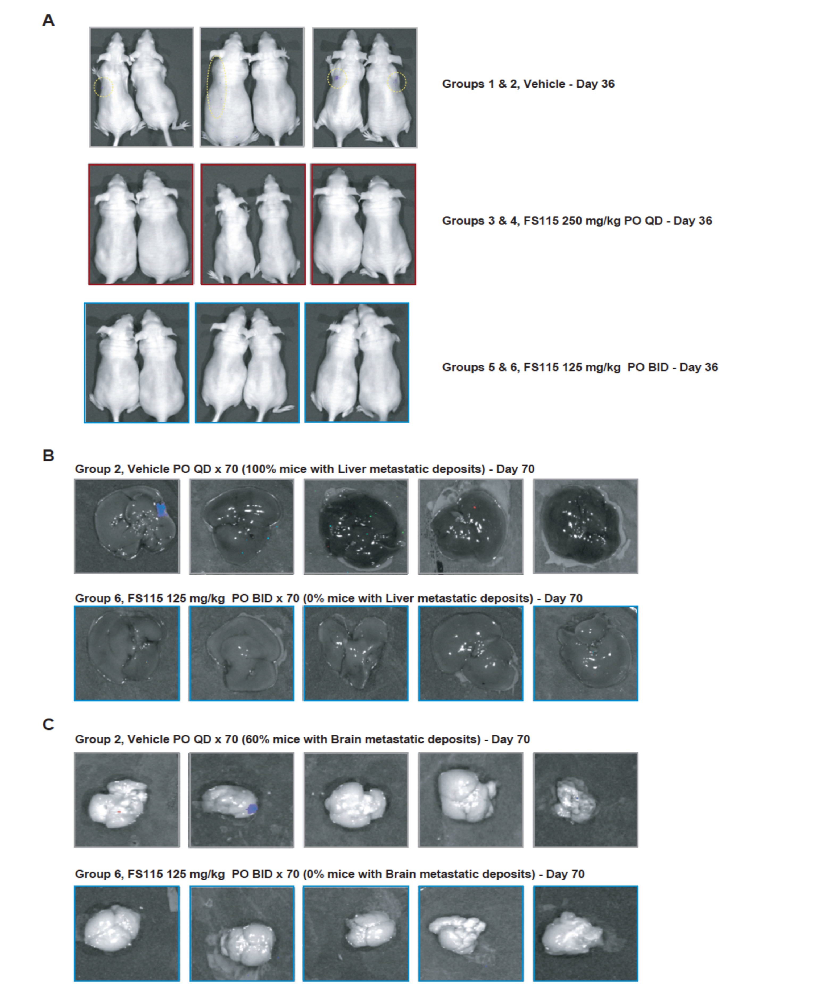

Supplementary Figure S2. FS-115 efficiently counteracts metastatic spread to distant organs. (A) Pictures show all animals from the experiment described in Figure 5 (except those reported in Figure 5), imaged using a Xenogen IVIS machine, after injection with D-luciferin, at day 36 from injection. (B) Pictures show livers from mice of two representative groups (Group 2, Vehicle QD, 70 days; and Group 6, FS-115 125mg/kg, BID, 70 days), from the experiment described in Figure 6. Mice were injected with D-luciferin before being culled, and then livers imaged using a Xenogen IVIS machine. (C) Same as in (B) except that brains were imaged.

www.impactaging.com 2 AGING, May 2016, Vol. 8 No.5

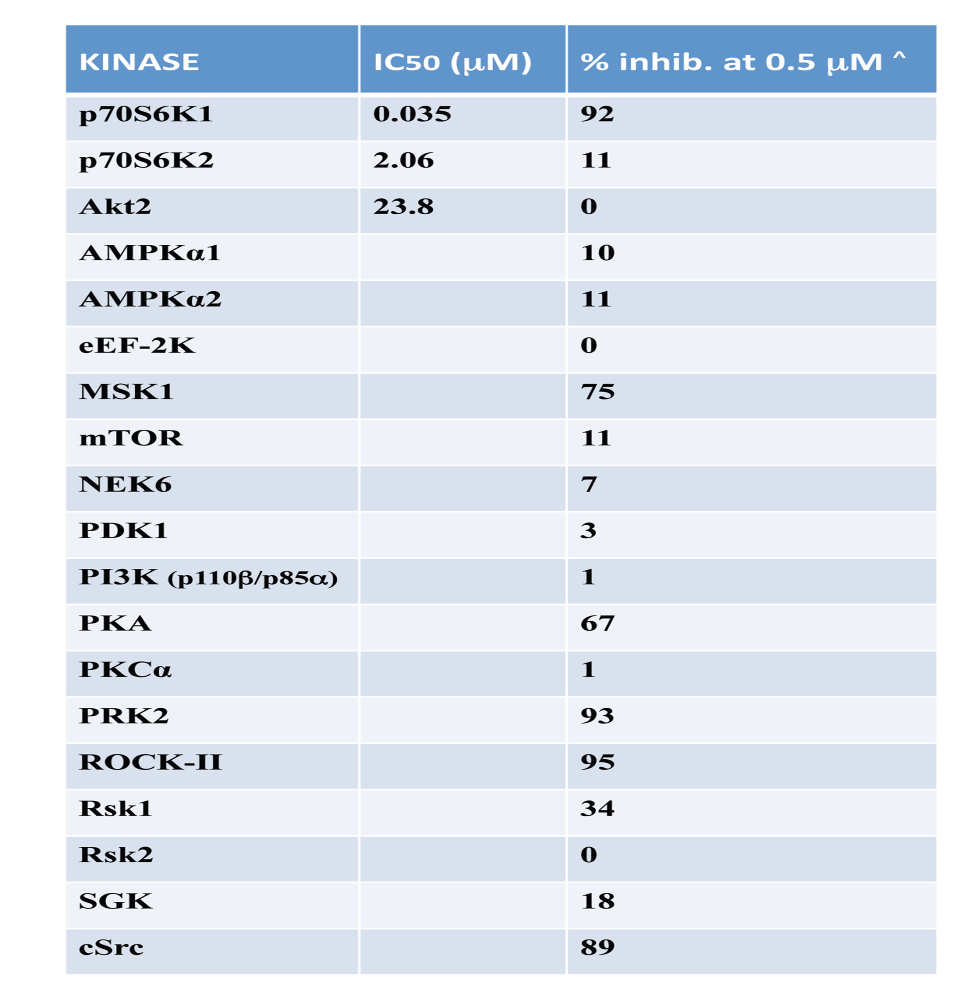

Supplementary Table S1. Inhibition of key kinases by FS-115. Table displays the IC50 (μM) and the percentage of inhibition of the indicated kinases, from the 268 tested in radiometric ATP-competitive kinase assay, using FS-115 at 0.5μM. Percentage inhibition represents the mean derived from a duplicate experiment.

www.impactaging.com 3 AGING, May 2016, Vol. 8 No.5

