SUPPLEMENTARY DATA

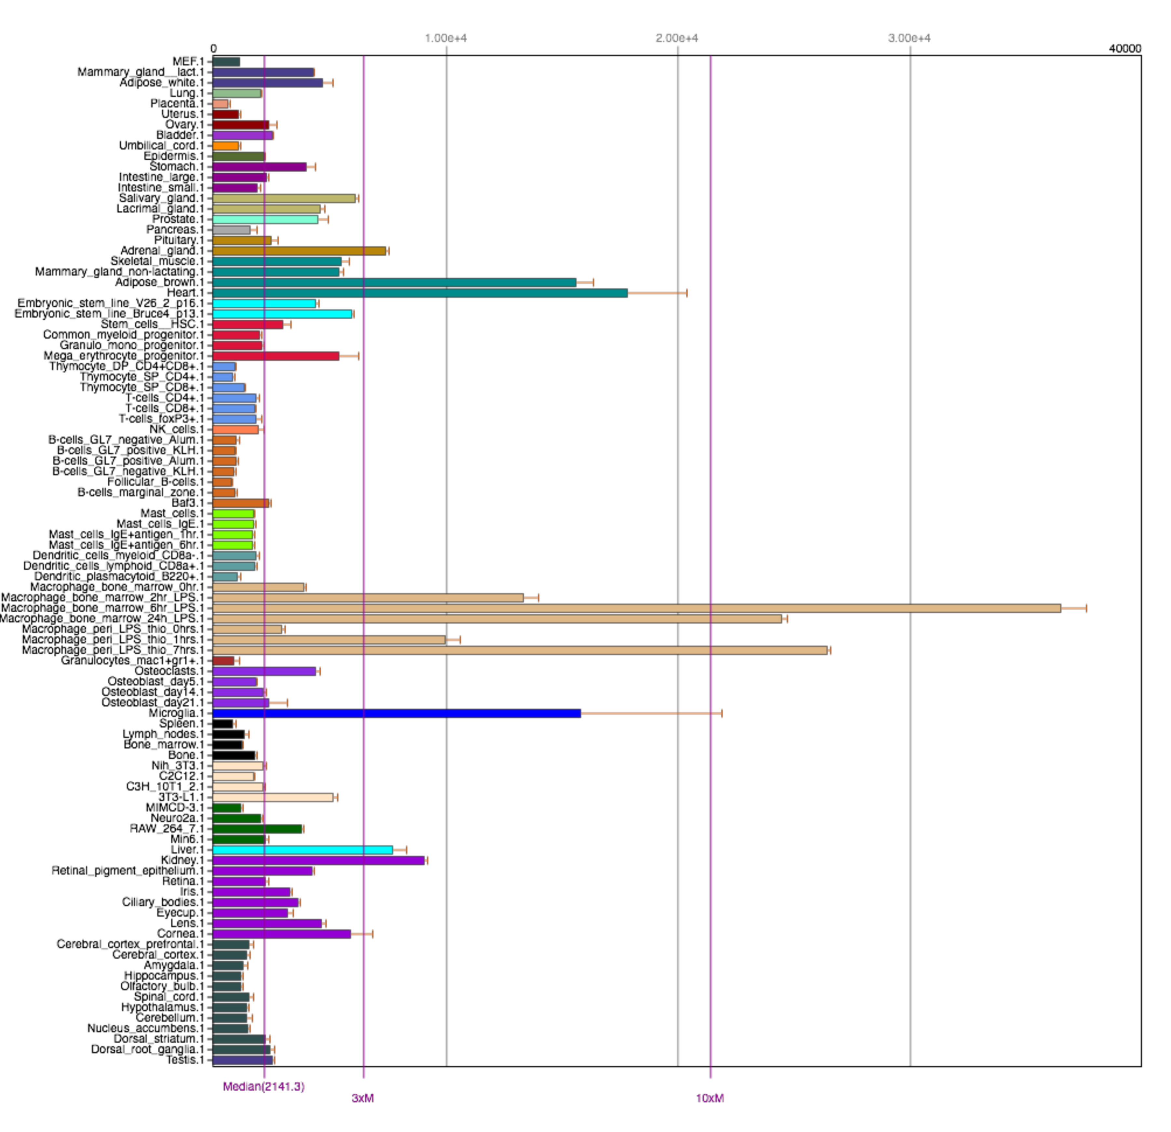

Figure S1. Tissue-specific mRNA expression of SOD2. Shown is mRNA expression of SOD2 in different mouse tissues. Data are generated from BioGPS (www.biogps.org).

www.impactaging.com 1 AGING, May 2016, Vol. 8 No.5

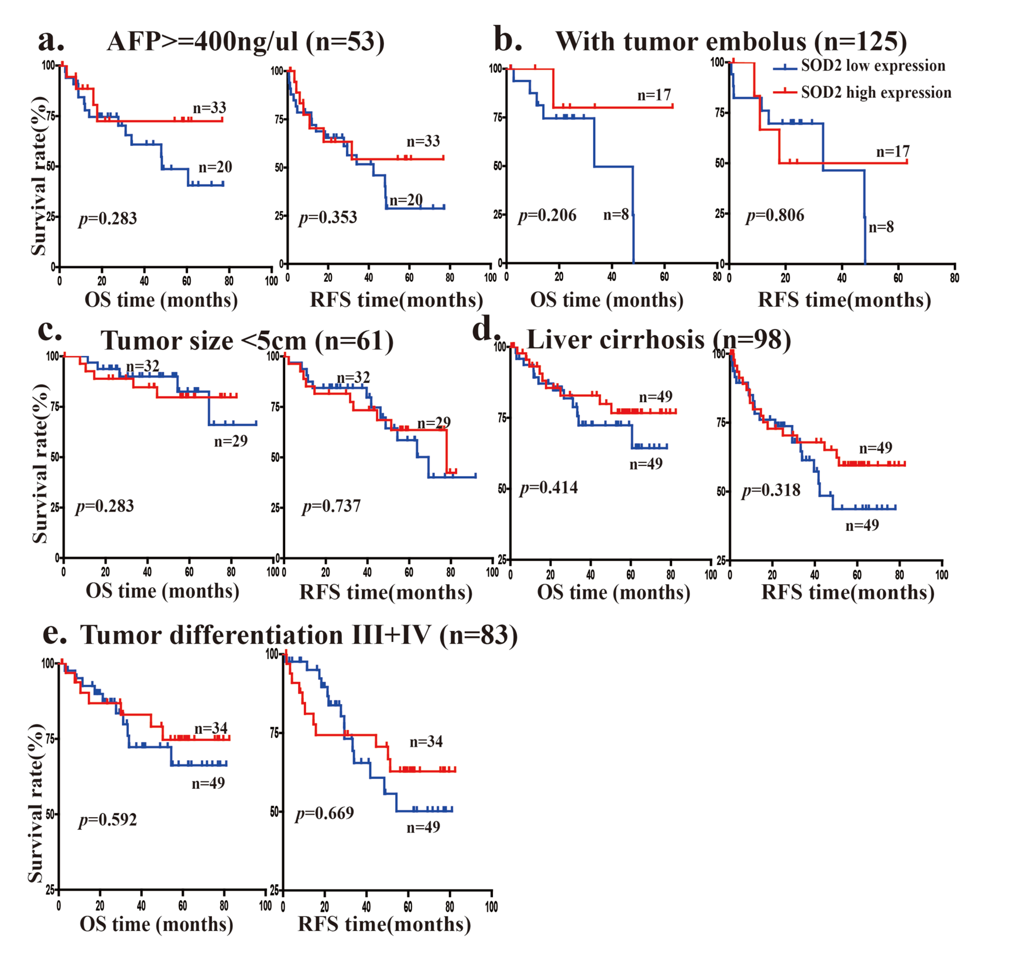

Figure S2. Overall survival (OS) and relapse-free survival (RFS) in advanced HCC patients with different SOD2 protein expression. The OS and RFS of 160 HCC patients with SOD2 high expression and low expression are analyzed in (a) patients with high AFP level (> 400 ng/μl), (b) patients without tumor embolus, (c) patients with tumor size < 5cm, (d) patients no liver cirrhosis, (e) patients with tumor differentiation III+IV.

www.impactaging.com 2 AGING, May 2016, Vol. 8 No.5

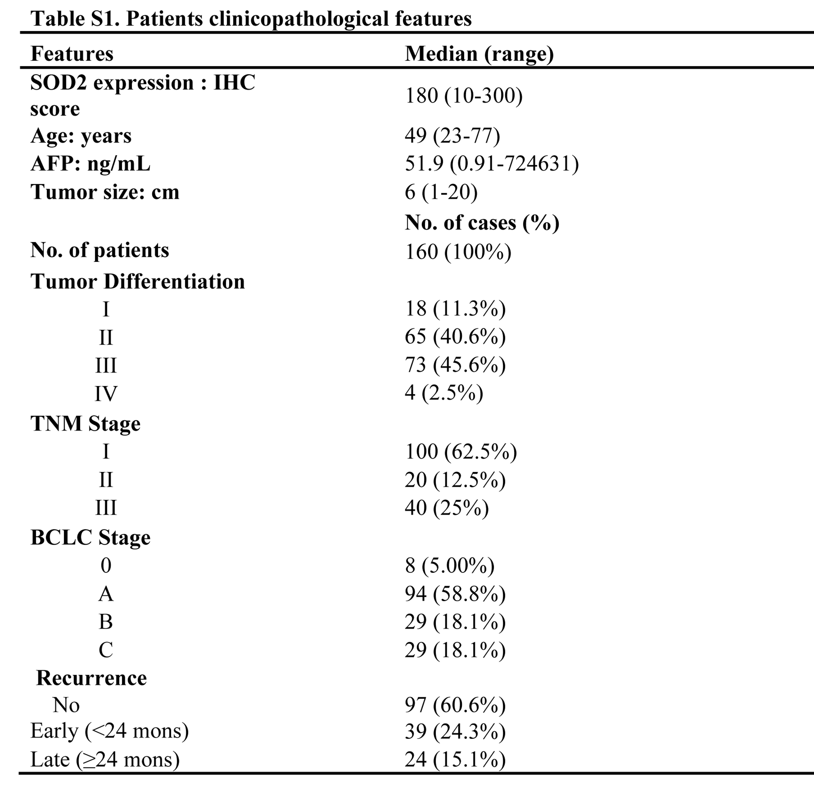

www.impactaging.com 3 AGING, May 2016, Vol. 8 No.5

