SUPPLEMENTARY DATA

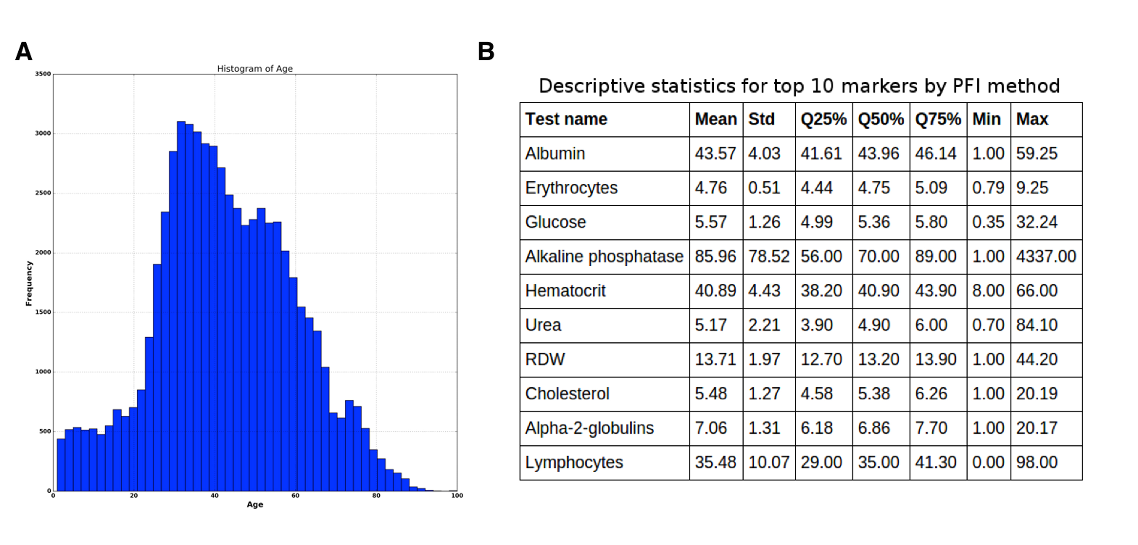

Figure S1. (A) Histogram of age distribution. (B) Table of descriptive statistic for top 10 markers.

Table S1. Table of hyperparameters. The best DNN in the ensemble has AdaGrad optimizer, PReLU activation function and 4 hidden layers with 2000, 1500, 1000, 500 neurons respectively and got 0.803 of R².

DNN architecture. Hidden units | Additional parameters. Activation function/Optimizer
DNN architecture. Hidden units | ReLU/AdaDelta | ReLU/AdaGrad | PReLU/AdaGrad
1000-1000-500 | 0.742 | 0.77 | 0.773
1000-1000-1000-500 | 0.745 | 0.782 | 0.792
1000-1000-1000-1000 | 0.75 | 0.784 | 0.785
1500-1500-1500-1500 | 0.754 | 0.791 | 0.795
2000-1500-1000-500 | 0.755 | 0.792 | 0.805
2500-2500-2500-2500 | 0.745 | 0.775 | 0.781

www.impactaging.com 1 AGING, May 2016, Vol. 8 No.5

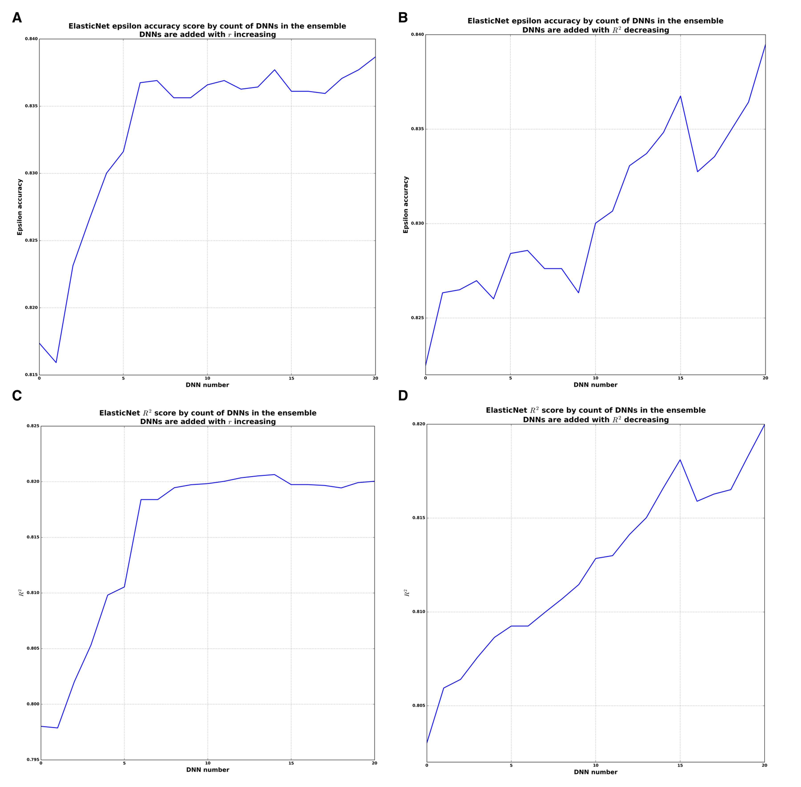

Figure S2. Analysis of the ensemble based on ElasticNet model. (A) Epsilon accuracy plot for constructing ensemble where DNNs are added with r increasing. (B) Epsilon accuracy plot for constructing ensemble where DNNs are added with R² decreasing. (C) R² plot for constructing ensemble where DNNs are added with r increasing. (D) R² plot for constructing ensemble where DNNs are added with R² decreasing,

www.impactaging.com 2 AGING, May 2016, Vol. 8 No.5

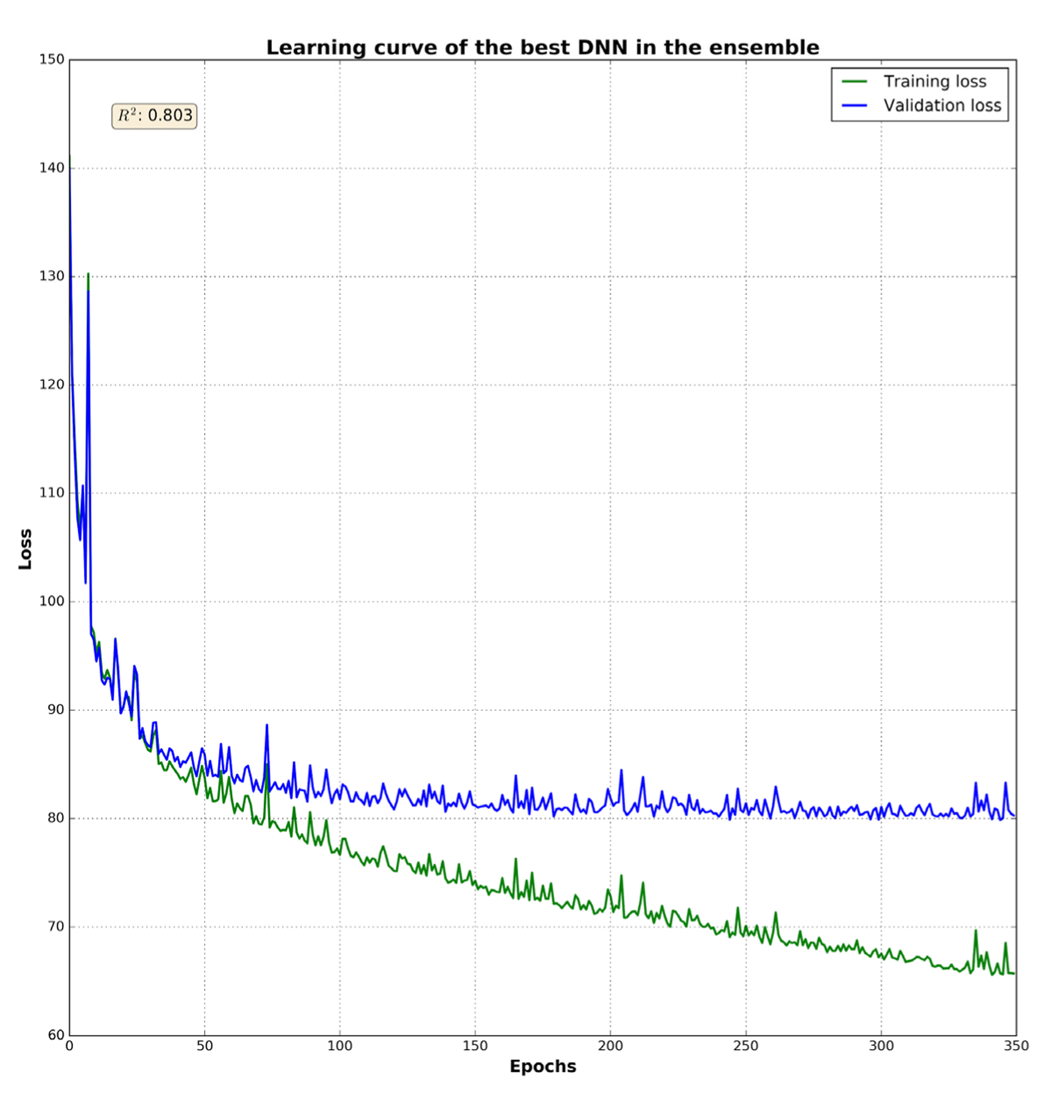

Figure S3. Learning curve of the best DNN in the ensemble. The green line is a training loss; blue is a validation loss. Training was stopped on 350 epoch because of reaching a plateau. The DNN got 0.803 of R².

www.impactaging.com 3 AGING, May 2016, Vol. 8 No.5

