SUPPLEMENTARY DATA

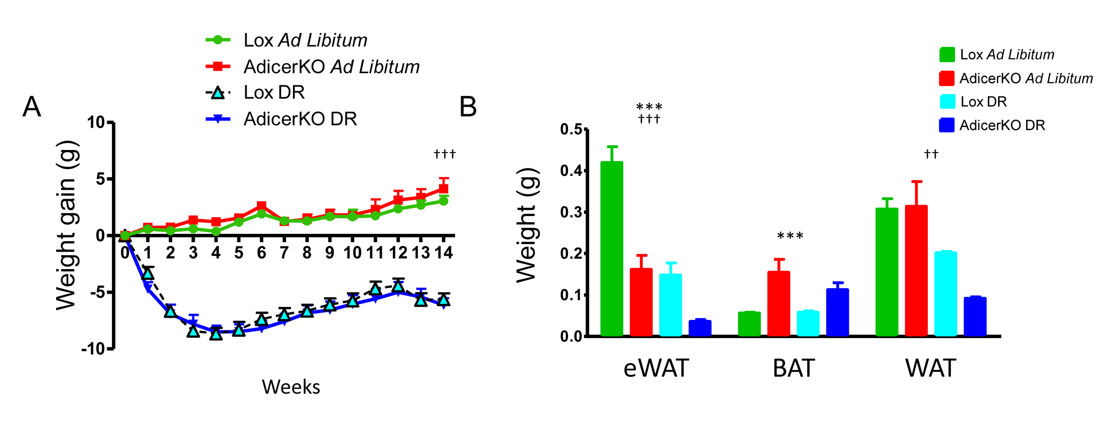

Supplementary Figure 1. Body weight and fat mass of AdicerKO mice. Twelve-week old mice were subjected to ad libitum (AL) or dietary restriction (DR) regimens for three months. (A) Body weight. (B) Fat mass (N=4-8 per condition). Mean ± SEM. *** P < 0.001 for genotype effect. †† P < 0.01, ††† P < 0.001 for diet effect. WAT, inguinal white adipose tissue. eWAT, epididymal white adipose tissue. BAT, interscapular brown adipose tissue.

Supplementary Table 1. Pathway analysis of serum metabolomics data comparing all conditions. Differentially expressed pathways when all conditions were compared (Lox AL, AdicerKO AL, Lox DR and AdicerKO DR).

Pathway Name | Total | Hits | p | FDR
Fatty acid metabolism | 39 | 1 | 0.012752 | 0.12663
Valine, leucine and isoleucine biosynthesis | 11 | 3 | 0.017801 | 0.12663
Valine, leucine and isoleucine degradation | 38 | 3 | 0.017801 | 0.12663
Pantothenate and CoA biosynthesis | 15 | 1 | 0.025044 | 0.12663
Glycerophospholipid metabolism | 30 | 2 | 0.026662 | 0.12663
Phenylalanine, tyrosine and tryptophan biosynthesis | 4 | 2 | 0.033377 | 0.12663
Phenylalanine metabolism | 11 | 2 | 0.033377 | 0.12663
Aminoacyl-tRNA biosynthesis | 69 | 17 | 0.04653 | 0.12663
Selenoamino acid metabolism | 15 | 1 | 0.047154 | 0.12663
Taurine and hypotaurine metabolism | 8 | 1 | 0.053879 | 0.12663
Primary bile acid biosynthesis | 46 | 1 | 0.053879 | 0.12663
Tyrosine metabolism | 44 | 1 | 0.056882 | 0.12663
Ubiquinone and other terpenoid-quinone biosynthesis | 3 | 1 | 0.056882 | 0.12663
Arachidonic acid metabolism | 36 | 1 | 0.058074 | 0.12663
Linoleic acid metabolism | 6 | 1 | 0.058074 | 0.12663
alpha-Linolenic acid metabolism | 9 | 1 | 0.058074 | 0.12663
Histidine metabolism | 15 | 4 | 0.059795 | 0.12663

www.impactaging.com 1 AGING, May 2016, Vol. 8 No.5

Arginine and proline metabolism | 44 | 9 | 0.18956 | 0.37912
Cysteine and methionine metabolism | 27 | 2 | 0.21403 | 0.40408
Glycine, serine and threonine metabolism | 31 | 2 | 0.22678 | 0.40408
Alanine, aspartate and glutamate metabolism | 24 | 5 | 0.2624 | 0.40408
Lysine biosynthesis | 4 | 1 | 0.27126 | 0.40408
Biotin metabolism | 5 | 1 | 0.27126 | 0.40408
Tryptophan metabolism | 40 | 3 | 0.27569 | 0.40408
Methane metabolism | 9 | 1 | 0.30306 | 0.40408
Cyanoamino acid metabolism | 6 | 1 | 0.30306 | 0.40408
Sphingolipid metabolism | 21 | 1 | 0.30306 | 0.40408
beta-Alanine metabolism | 17 | 3 | 0.37459 | 0.47022
Lysine degradation | 23 | 2 | 0.37879 | 0.47022
Glutathione metabolism | 26 | 4 | 0.39554 | 0.47464
Nitrogen metabolism | 9 | 3 | 0.5897 | 0.68481
Butanoate metabolism | 22 | 1 | 0.63277 | 0.6903
Porphyrin and chlorophyll metabolism | 27 | 1 | 0.63277 | 0.6903
D-Glutamine and D-glutamate metabolism | 5 | 2 | 0.84868 | 0.89236
Purine metabolism | 68 | 1 | 0.89236 | 0.89236
Pyrimidine metabolism | 41 | 1 | 0.89236 | 0.89236

www.impactaging.com 2 AGING, May 2016, Vol. 8 No.5

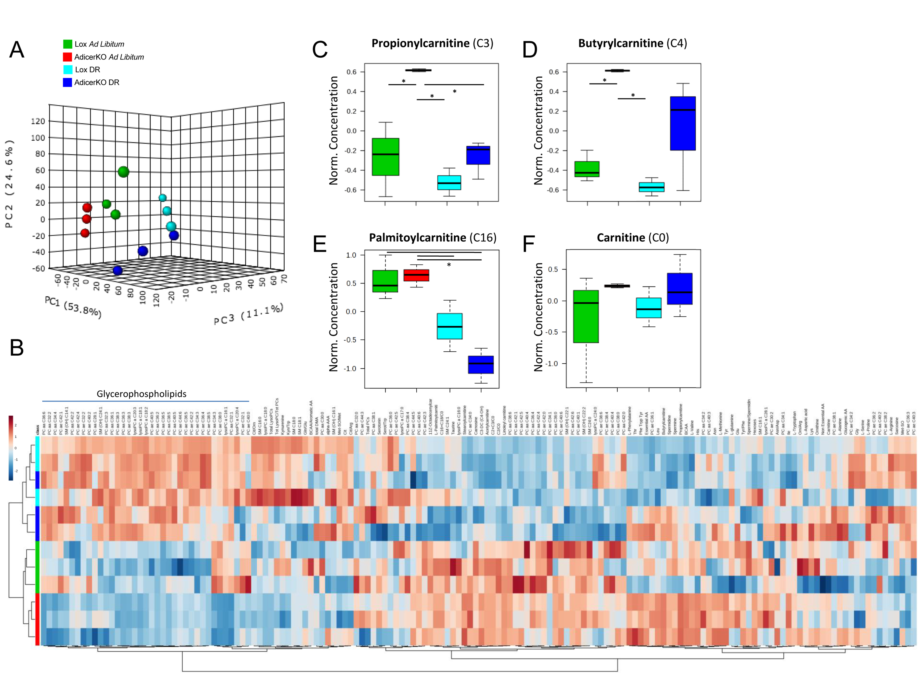

Supplementary Figure 2. Serum metabolite changes in AdicerKO mice. Twelve-week old mice were subjected to ad libitum (AL) or dietary restriction (DR) regimens for three months. Mice were euthanized at the end of the protocol after overnight fasting and metabolomics was conducted in the serum samples. Values were normalized by the average of the Lox AL group, Log2 transformed and Pareto scaled. Data was subjected to (A) Partial Least Squares Discriminant Analysis (PLS-DA) and (B) Hierarchical Clustering Analysis. (C-F) Selected metabolites. N=3 per condition. Data are mean ± SE. * P < 0.05.

www.impactaging.com 3 AGING, May 2016, Vol. 8 No.5

Supplementary Table 2. Pathway analysis of serum metabolomics data in AdicerKO mice. Differentially expressed pathways when Lox ad libitum and AdicerKO ad libitum were compared.

Pathway Name | Total | Hits | p | FDR
Valine, leucine and isoleucine biosynthesis | 11 | 3 | 2.20E-04 | 0.0039647
Valine, leucine and isoleucine degradation | 38 | 3 | 2.20E-04 | 0.0039647
Phenylalanine, tyrosine and tryptophan biosynthesis | 4 | 2 | 0.058927 | 0.44812
Phenylalanine metabolism | 11 | 2 | 0.058927 | 0.44812
Selenoamino acid metabolism | 15 | 1 | 0.078201 | 0.44812
Aminoacyl-tRNA biosynthesis | 69 | 17 | 0.0869 | 0.44812
Tyrosine metabolism | 44 | 1 | 0.099581 | 0.44812
Ubiquinone and other terpenoid-quinone biosynthesis | 3 | 1 | 0.099581 | 0.44812
Pantothenate and CoA biosynthesis | 15 | 1 | 0.11684 | 0.46735
Alanine, aspartate and glutamate metabolism | 24 | 5 | 0.21123 | 0.7081
Tryptophan metabolism | 40 | 3 | 0.21636 | 0.7081
Cysteine and methionine metabolism | 27 | 2 | 0.25371 | 0.73455
Arachidonic acid metabolism | 36 | 1 | 0.30606 | 0.73455
Linoleic acid metabolism | 6 | 1 | 0.30606 | 0.73455
alpha-Linolenic acid metabolism | 9 | 1 | 0.30606 | 0.73455
Glycerophospholipid metabolism | 30 | 2 | 0.37639 | 0.77163
Histidine metabolism | 15 | 4 | 0.38953 | 0.77163
Nitrogen metabolism | 9 | 3 | 0.41275 | 0.77163
beta-Alanine metabolism | 17 | 3 | 0.41291 | 0.77163
Arginine and proline metabolism | 44 | 9 | 0.48213 | 0.77163
Lysine degradation | 23 | 2 | 0.49067 | 0.77163
Glutathione metabolism | 26 | 4 | 0.50355 | 0.77163
Purine metabolism | 68 | 1 | 0.53907 | 0.77163
Pyrimidine metabolism | 41 | 1 | 0.53907 | 0.77163
Butanoate metabolism | 22 | 1 | 0.57659 | 0.77163
Porphyrin and chlorophyll metabolism | 27 | 1 | 0.57659 | 0.77163
D-Glutamine and D-glutamate metabolism | 5 | 2 | 0.57872 | 0.77163
Methane metabolism | 9 | 1 | 0.66013 | 0.79215
Cyanoamino acid metabolism | 6 | 1 | 0.66013 | 0.79215
Sphingolipid metabolism | 21 | 1 | 0.66013 | 0.79215
Glycine, serine and threonine metabolism | 31 | 2 | 0.69424 | 0.80621
Fatty acid metabolism | 39 | 1 | 0.76257 | 0.85789
Taurine and hypotaurine metabolism | 8 | 1 | 0.89892 | 0.92402
Primary bile acid biosynthesis | 46 | 1 | 0.89892 | 0.92402
Lysine biosynthesis | 4 | 1 | 0.92402 | 0.92402
Biotin metabolism | 5 | 1 | 0.92402 | 0.92402

www.impactaging.com 4 AGING, May 2016, Vol. 8 No.5

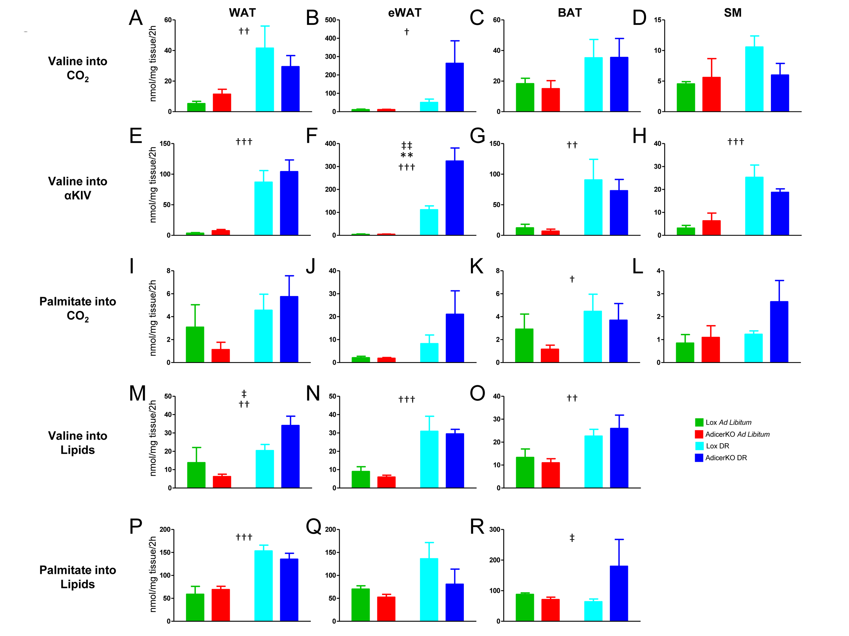

Supplementary Figure 3. Substrate oxidation and lipid synthesis in WAT of AdicerKO mice. Twelve-week old mice were subjected to ad libitum (AL) or dietary restriction (DR) regimens for one month. At the end of the protocol, tissues were isolated, minced and explants were used to assess (A-D) complete oxidation of valine, (E-H) oxidation of valine into α-ketoisovaleric acid (αKIV), (I-L) complete oxidation of palmitate, (M-O) lipid synthesis from valine, and (P-R) lipid synthesis from palmitate. WAT, inguinal white adipose tissue. eWAT, epididymal white adipose tissue. BAT, interscapular brown adipose tissue. SM, gastrocnemius skeletal muscle. N=3-5 per condition. Mean ± SEM. ** P < 0.01 for genotype effect; † P < 0.05, †† P < 0.01, ††† P < 0.001 for diet effect; ‡ P < 0.05, ‡‡ P < 0.01 for diet-genotype interaction.

www.impactaging.com 5 AGING, May 2016, Vol. 8 No.5

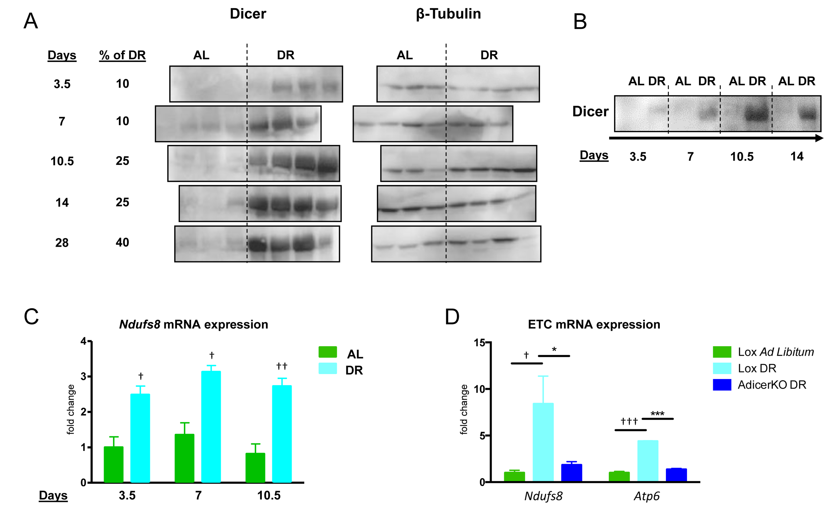

Supplementary Figure 4. Kinetics of Dicer and mitochondrial gene expression in WAT upon DR. Twelve-week old C57BL/6 mice were subjected to ad libitum (AL) or dietary restriction (DR) regimens for up to one month. Mice were euthanized at different time-points and WAT was collected. (A) Western blotting for Dicer and β-tubulin. (B) Representative blot. (C,D) Gene expression of components of the Electron Transport Chain (ETC) was assessed by RT-qPCR (N=3-5 per condition). Mean ± SEM. * P < 0.05, *** P < 0.05 for genotype effect; † P < 0.05, †† P < 0.01, ††† P < 0.001 for diet effect.

www.impactaging.com 6 AGING, May 2016, Vol. 8 No.5

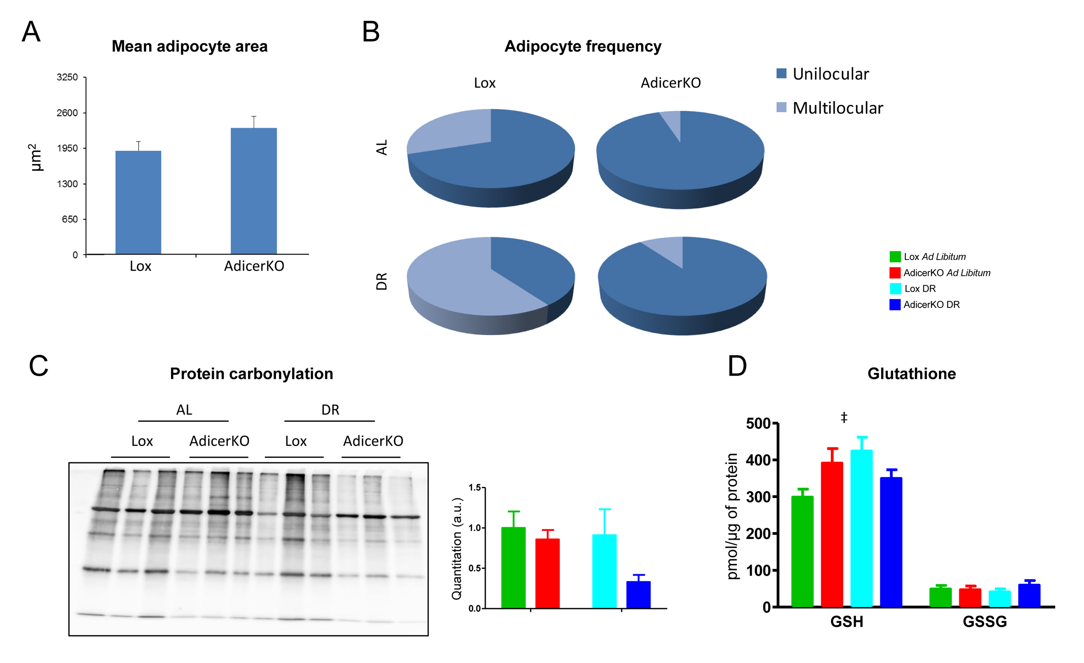

Supplementary Figure 5. Adipocyte size and redox balance of WAT of AdicerKO mice. Twelve-week old mice were subjected to ad libitum (AL) or dietary restriction (DR) regimens for one month and WAT was isolated. (A,B) Tissue was processed for H&E staining and (A) mean adipocyte size and (B) adipocyte type were blindly assessed using microscopic images (N=4-5 animals per condition, one image per animal collected always in the same anatomical location, i.e. around the inguinal lymph node). (C) Overall protein carbonylation was assessed by immunoblot and quantitated (right panel) using image densitometry. (D) Reduced (GSH) and oxidized (GSSG) glutathione levels were measured in tissue extracts (N=3-5 animals per condition). Mean ± SEM. ‡ P < 0.05 for diet-genotype interaction.

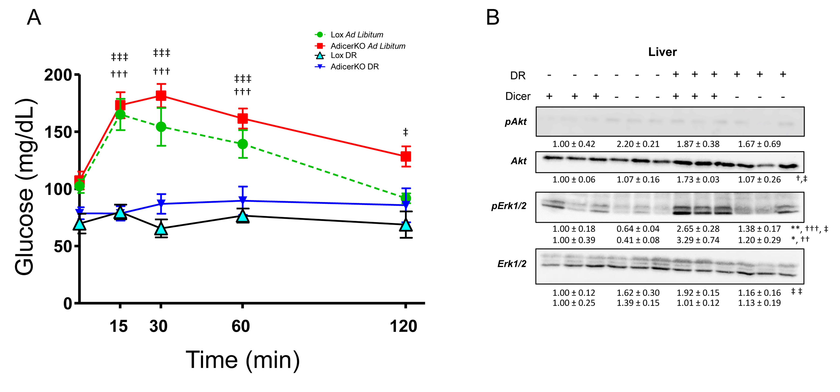

Supplementary Figure 6. Glucose tolerance test and liver insulin signaling in AdicerKO mice. Twelve-week old mice were subjected to ad libitum (AL) or dietary restriction (DR) regimens for three (A) or one (B) month. (A) Glucose tolerance test was performed one week prior to the end of the protocol (N=5-7 per condition). Mean ± SEM. ††† P < 0.001 Lox AL vs. Lox DR; ‡ P < 0.05, ‡‡‡ P < 0.001 AdicerKO AL vs. AdicerKO DR. (B) Western blots of liver extracts pAkt, phospho-Akt. pErk1/2, phospho-Erk1/2. Numbers are quantitation of blots (fold expression in comparison to control group) ± SEM. * P < 0.05, ** P < 0.01 for genotype effect; †† P < 0.01, ††† P < 0.001 for diet effect; ‡ P < 0.05, ‡‡ P < 0.01 for diet-genotype interaction.

www.impactaging.com 7 AGING, May 2016, Vol. 8 No.5

